TIMELINE SHOWCASING THE EVOLUTION OF CYBERSECURITY

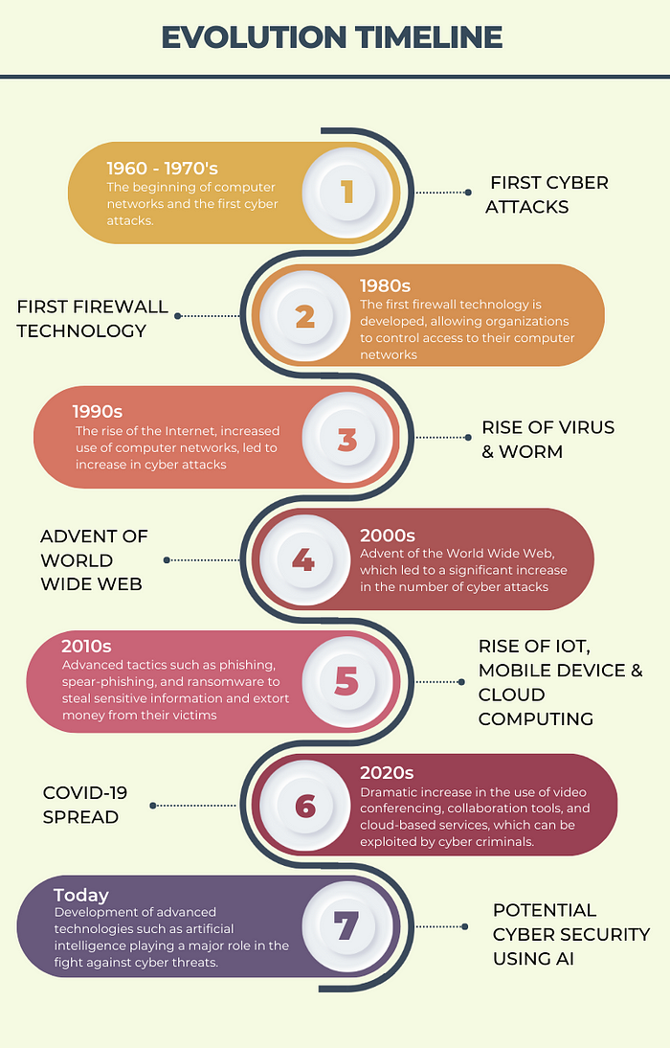

**Early Years (1960s-1980s)**

1. 1969: The first network, ARPANET, is developed, laying the foundation for the modern internet.

2. 1971: The first email is sent over ARPANET by Ray Tomlinson.

3. 1973: The first firewall is developed by Bolt Beranek and Newman (BBN).

4. 1983: The first computer virus, "Elk Cloner," is discovered.

5. 1988: The Morris Worm is released, highlighting the need for cybersecurity measures.

**Growth and Expansion (1990s-2000s)**

1. 1990: The World Wide Web (WWW) is invented by Tim Berners-Lee.

2. 1991: The first SSL (Secure Sockets Layer) encryption is developed.

3. 1993: The first cyberattack on a commercial website occurs.

4. 1995: The first antivirus software is developed.

5. 1998: The first DDoS (Distributed Denial of Service) attack is reported.

6. 2000: The "I Love You" virus spreads rapidly, infecting millions of computers.

**Modern Era (2010s-present)**

1. 2010: The Stuxnet worm is discovered, highlighting the threat of nation-state cyberattacks.

2. 2011: The first major cloud security breach occurs (Dropbox).

3. 2013: Edward Snowden reveals widespread government surveillance, sparking concerns about data privacy.

4. 2014: The Heartbleed bug is discovered, exposing vulnerabilities in OpenSSL encryption.

5. 2015: The first major ransomware attack occurs (Cryptolocker).

6. 2017: The WannaCry ransomware attack spreads globally, infecting over 200,000 computers.

7. 2020: The COVID-19 pandemic accelerates the shift to remote work, increasing cybersecurity risks.

**Key Technology Advancements**

1. Encryption: Development of encryption algorithms like AES, RSA, and elliptic curve cryptography.

2. Firewalls: Advancements in firewall technology, including next-generation firewalls (NGFWs).

3. Intrusion Detection and Prevention Systems (IDPS): Development of IDPS to detect and prevent network intrusions.

4. Cloud Security: Evolution of cloud security measures, including cloud access security brokers (CASBs) and cloud workload protection platforms (CWPPs).

5. Artificial Intelligence and Machine Learning: Integration of AI and ML in cybersecurity solutions to improve threat detection and incident response.

Pivotal Moments

1. Formation of the Internet Society (ISOC)*: Established in 1992 to promote internet standards and security.

2. Creation of the SANS Institute: Founded in 1989 to provide cybersecurity training and research.

3. Establishment of the National Institute of Standards and Technology (NIST) Cybersecurity Framework: Published in 2014 to provide guidelines for cybersecurity risk management.